WAF & SYSTEMS MANAGER PARAMETER STORE

AWS WAF — Web Application Firewall
AWS WAF (Web Application Firewall) is an AWS service used to protect web applications from common web attacks.
It can inspect incoming HTTP/HTTPS requests and allow, block, or count requests based on configured rules.

Common use cases
- Protect applications from SQL Injection
- Protect against Cross-Site Scripting (XSS)
- Block requests from specific IP addresses
- Allow/block traffic based on countries
- Rate-limit excessive requests
- Protect applications behind:
  - Application Load Balancer (ALB)
  - Amazon CloudFront
  - API Gateway

Important AWS WAF components
Component | Purpose
Web ACL | Main security policy
Rule | Defines what traffic should be allowed/blocked
Rule Group | Collection of related rules
IP Set | List of IP addresses
Managed Rules | AWS/third-party predefined protections
Action | Allow, Block, Count, CAPTCHA, Challenge

Basic flow
Client
|
| HTTP/HTTPS Request
↓
AWS WAF
|
|---- Block malicious request
|
|---- Allow legitimate request
↓
ALB / CloudFront / API Gateway
|
↓
Application

TASK : Create a Web ACL and Protect an Application Load Balancer

Objective
To create an AWS WAF Web ACL, configure a managed rule, and associate it with an Application Load Balancer.

Prerequisites
- AWS account
- AWS Console access
- IAM permissions for WAF
- Existing Application Load Balancer
- Application running behind the ALB
- AWS Region selected

Step-by-Step Implementation

Step 1 — Open AWS WAF
Go to:
AWS Console → WAF & Shield
Select:
AWS WAF → Web ACLs
Click:
Create web ACL

Step 2 — Configure Web ACL
Enter:
Resource type:
Regional resources

Region:
ap-south-1
Give a name:
My-Web-ACL
For the resource type, select:
Application Load Balancer
Click Next.
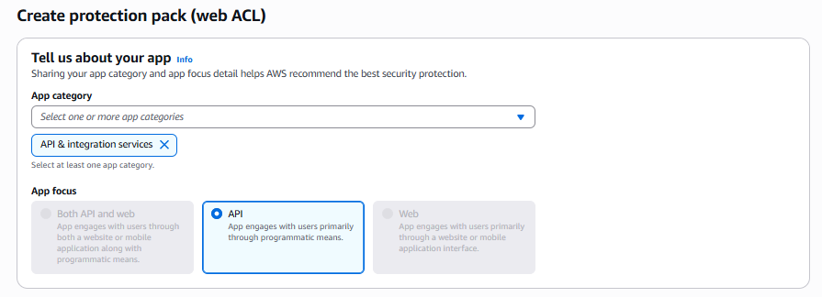
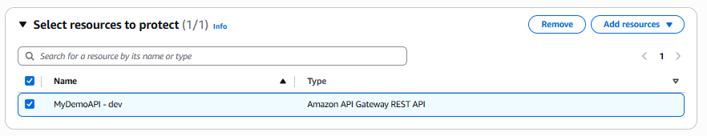
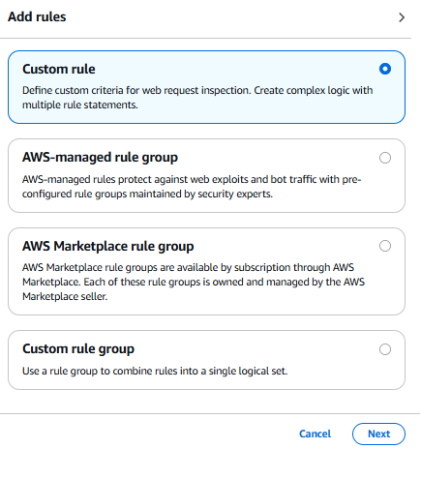

Step 3 — Associate the ALB
Select your existing:
Application Load Balancer
Click Next.
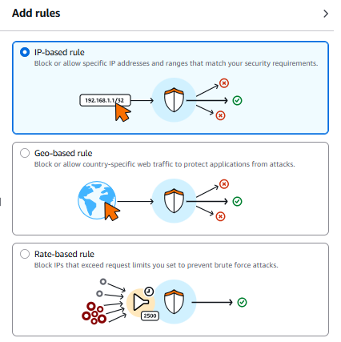

Step 4 — Add AWS Managed Rule
Under Rules, select:
Add rules → Add managed rule groups
Choose an AWS managed rule group such as:
AWS Managed Rules
→ Core rule set
Enable the rule group.
For a lab, you can initially use:
Action: Count
This allows you to observe matching requests without immediately blocking them.
Click Next.

Step 5 — Configure Default Action
Set:
Default action: Allow
This means normal requests are allowed unless a rule matches them.
Click Next.

Step 6 — Review
Review:
Web ACL name: My-Web-ACL
Resource: Application Load Balancer
Default action: Allow
Rules: AWS Managed Core Rule Set
Click:
Create web ACL

Step 7 — Test
Open your ALB DNS name:
http://<ALB-DNS-NAME>
Verify that your application is accessible.
Then go to:
AWS WAF
→ Web ACLs
→ My-Web-ACL
→ Overview
You can monitor:
- Allowed requests
- Blocked requests
- Counted requests
- Rule matches

Expected Result
The Web ACL is successfully created and associated with the ALB.
Internet
↓
AWS WAF
↓
ALB
↓
Application

AWS WAF TASK 2

Block a Specific IP Address Using AWS WAF

Objective
To create an IP Set and configure AWS WAF to block requests coming from a specific IP address.

Prerequisites
- AWS account
- AWS WAF permissions
- Existing Web ACL
- ALB/CloudFront/API Gateway protected by WAF
- IP address for testing

Step-by-Step Implementation

Step 1 — Create IP Set
Go to:
AWS WAF → IP sets
Click:
Create IP set
Enter:
IP set name:
Blocked-IP-Set

Region:
ap-south-1

IP version:
IPv4
Enter an IP address in CIDR format:
203.0.113.10/32
For your actual lab, replace this with the IP you want to block.
Click:
Create IP set

Step 2 — Open Web ACL
Go to:
AWS WAF
→ Web ACLs
→ My-Web-ACL
Click:
Add rules → Add my own rules and rule groups
Choose:
IP set

Step 3 — Configure Rule
Rule name:
Block-Specific-IP
Select:
IP set:
Blocked-IP-Set
Set action:
Block
Click Add rule.

Step 4 — Set Rule Priority
Make sure:
Block-Specific-IP
has an appropriate priority before the default Allow action.

Step 5 — Save Web ACL
Click:
Save

Step 6 — Test
Send a request from the blocked IP.
Expected result:
HTTP 403 Forbidden
The request flow becomes:
Client
↓
AWS WAF
↓
IP matches Blocked-IP-Set
↓
BLOCK
↓
403 Forbidden

Expected Result
The specified IP address is successfully blocked from accessing the protected application.

2. AWS Systems Manager Parameter Store

Brief Documentation
AWS Systems Manager Parameter Store is a capability of AWS Systems Manager that provides secure, centralized storage for configuration values and secrets.
Applications can retrieve parameters at runtime instead of hard-coding configuration values.

Examples
You can store:
/application/name
/application/environment
/database/host
/database/port
/application/api-url
Sensitive values can be stored as:
SecureString
and encrypted using AWS KMS.

Parameter types
Type | Purpose
String | Normal text
StringList | Comma-separated values
SecureString | Sensitive information

Example
Instead of putting this directly into an application:
DB_PASSWORD=MyPassword123
Store it in Parameter Store:
/myapp/prod/db/password
The application retrieves it when required.

Basic architecture
Application / EC2 / Lambda
|
↓
IAM Permission
|
↓
SSM Parameter Store
|
↓
KMS Encryption

SYSTEMS MANAGER PARAMETER STORE — TASK 1

Create and Retrieve Parameters

Objective
To create parameters in AWS Systems Manager Parameter Store and retrieve their values using the AWS Management Console and AWS CLI.

Prerequisites
- AWS account
- AWS Console access
- IAM permissions for Systems Manager
- AWS CLI installed
- AWS CLI configured
Verify:
aws sts get-caller-identity

Step-by-Step Implementation

Step 1 — Open Parameter Store
Go to:
AWS Console → Systems Manager

Navigate to:
Parameter Store
Click:
Create parameter


Step 2 — Create a String Parameter
Enter:
Name:
/myapp/environment

Tier:
Standard

Type:
String

Value:
dev
Click:
Create parameter

Step 3 — Create Another Parameter
Create:
Name:
/myapp/application-name

Type:
String

Value:
MyWebApplication
Click Create parameter.
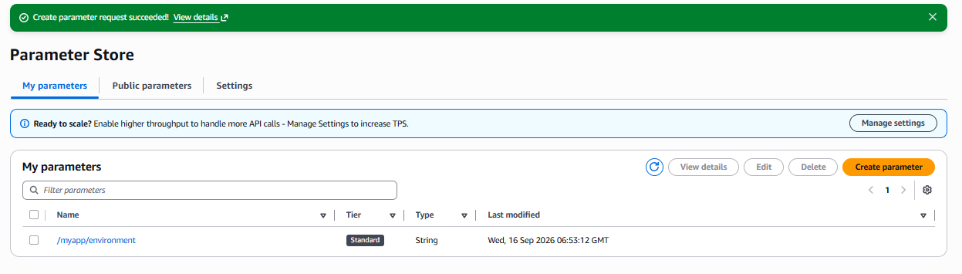

Step 4 — Retrieve Parameter from Console
Go to:
Systems Manager
→ Parameter Store
Select:
/myapp/environment
You should see:
Value: dev

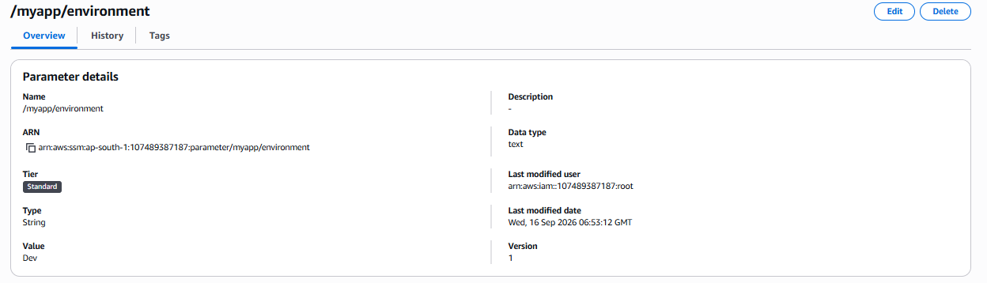

Step 5 — Retrieve Only the Value
Run:
aws ssm get-parameter \
--name "/myapp/environment" \
--query "Parameter.Value" \
--output text
Expected:
dev

Expected Result
The configuration value is successfully stored in Parameter Store and retrieved without hard-coding it into the application.

TASK 2 SYSTEMS MANAGER PARAMETER STORE

Store a SecureString Parameter Using KMS

Objective
To securely store a sensitive configuration value as a SecureString parameter and retrieve it using IAM permissions.

Prerequisites
- AWS account
- Systems Manager permissions
- IAM permissions
- KMS permissions
- AWS CLI configured
- Existing KMS key or AWS managed SSM KMS key

Step-by-Step Implementation

Step 1 — Open Parameter Store
Go to:
AWS Console
→ Systems Manager
→ Parameter Store
Click:
Create parameter
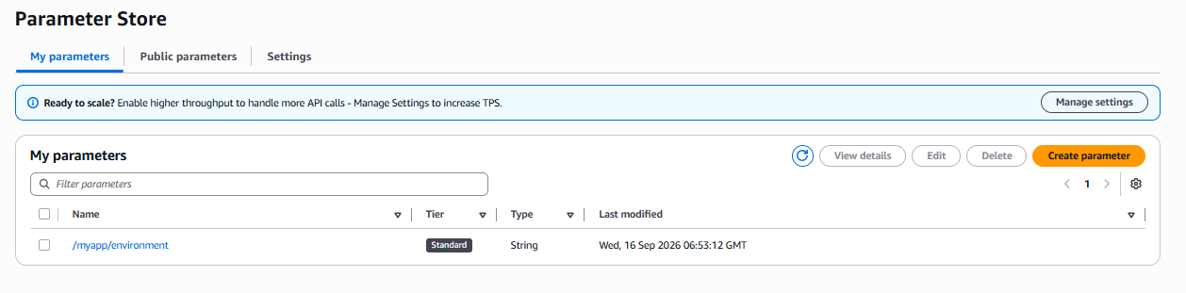

Step 2 — Configure Secure Parameter
Enter:
Name:
/myapp/prod/db-password

Tier:
Standard

Type:
SecureString
For encryption key, select:
aws/ssm
or your customer-managed KMS key.
Enter a lab password, for example:
MyDBPassword@123
Click:
Create parameter
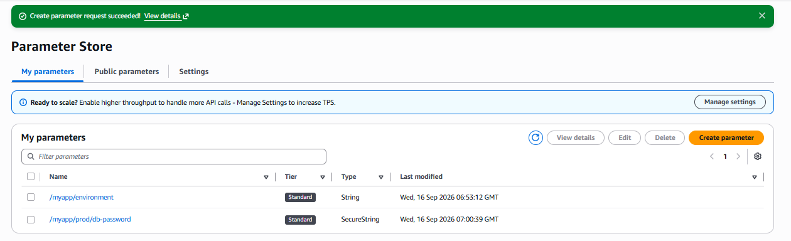

Step 3 — Verify Parameter
Go to:
Parameter Store
→ /myapp/prod/db-password
The value is stored as an encrypted SecureString.

Step 4 — Retrieve SecureString Using CLI
Run:
aws ssm get-parameter \
--name "/myapp/prod/db-password" \
--with-decryption

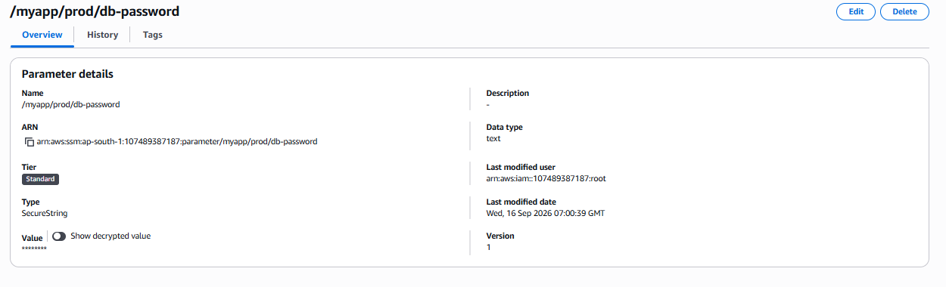
The decrypted value will be returned if your IAM identity has the required permissions.

Step 5 — Retrieve Only the Value
aws ssm get-parameter \
--name "/myapp/prod/db-password" \
--with-decryption \
--query "Parameter.Value" \
--output text
Expected:
MyDBPassword@123

Step 6 — Understand the IAM Permissions
The IAM user/role retrieving the parameter needs permissions similar to:
{
"Effect": "Allow",
"Action": [
"ssm:GetParameter"
],
"Resource": "arn:aws:ssm:ap-south-1:ACCOUNT_ID:parameter/myapp/prod/db-password"
}
If using a customer-managed KMS key, the identity also needs appropriate KMS permissions such as:
kms:Decrypt

AWS WAF
Question: Why do we use AWS WAF?
Answer:
AWS WAF is used to protect web applications from malicious HTTP/HTTPS traffic. We can create rules to block SQL injection, XSS, unwanted IP addresses, excessive requests, and other web-based attacks. It can be associated with services such as ALB, CloudFront, and API Gateway.

Parameter Store
Question: Why do we use Systems Manager Parameter Store?
Answer:
Parameter Store provides centralized storage for application configuration and sensitive values. Instead of hard-coding database passwords, URLs, environment values, or other configuration in application code, we store them as parameters and allow applications to retrieve them securely through IAM. Sensitive values can be stored as SecureString and encrypted using KMS.

WAF vs Parameter Store
AWS WAF | Parameter Store
Web application security | Configuration management
Filters HTTP/HTTPS requests | Stores configuration values
Blocks malicious traffic | Provides values to applications
Uses Web ACLs and Rules | Uses Parameters
Protects ALB/CloudFront/API Gateway | Used by EC2/Lambda/applications
Example: Block IP | Example: Store DB password

